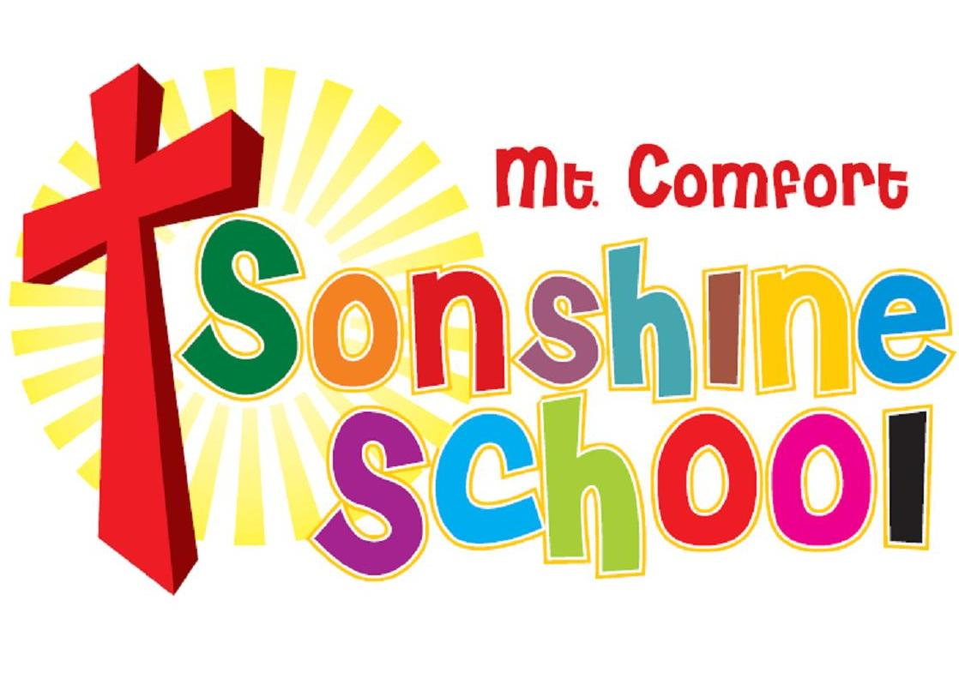
Summer 2025 Enrollment

For this summer, we are trying something new. We will offer 2 types of care: MWF only or all 5 days M-F from 9:00-1:00 for infants 4 months old-graduating kindergartners. There will be no aftercare offered this summer. We have split the months of June and July into 9 weeks. You will sign your child up for whichever weeks you would like to have him/her attend. On June 1, you will be billed for weeks 1-4 and on July 1, you will be billed for weeks 5-9. The tuition is $80/week for MWF and $115/week for M-F. During the summer, we do not offer any sibling discount or a member of Mt Comfort Church of Christ discount; however, we do not collect registration or supply fees. Please see the following list for the breakdown of weekly sessions.

Week 1: June 2-June 6
Week 2: June 9-June 15
Week 3: June 16-June 20
Week 4: June 23-June 27
Week 5: June 30-July 3 (closed on July 4, not pro-rated)
Week 6: July 7-July 11
Week 7: July 14-July 18
Week 8: July 21-July 25
Week 9: July 28-August 1

Registration will open on February 15 for current students and church members. It will be open to the public on March 1. Links will be available on our website as well as through brightwheel. Please reach out to the office if you have any questions.

Lyndsey Stout, Director lstout@mtcomfortsonshineschool.org
Linda Profitt, Admin Assistant mcccsonshineschool@swbell.net
Melinda Mahaffey, Admin Assistant mmahaffey@mtcomfortsonshineschool.org

